**Tendulkar, Vijay** **(1928-2008)**

Vijay Tendulkar was an Indian playwright, screen and television writer, literary essayist, fiction writer, political journalist, and social commentator whose work in multiple genres represents one of the most versatile and distinguished creative careers of the post-independence period shaped broadly by the aesthetics and politics of modernism. From the early 1950s until his death in 2008, he was a singularly influential theatre figure in Marathi—the principal language of the state of Maharashtra—which has a millennium-long literary history and more than seventy million speakers. Tendulkar’s screenplays, in contrast, were written for films in Hindi, India’s majority language and the preferred medium of the world’s largest film industry. In the urban as well as non-urban settings of his plays and screenplays, he employed forms of social realism tempered with powerfully poetic structures of imagery, thought, and experience, and emerged as independent India’s first ‘national’ playwright because of the depth and breadth of his engagement with the particulars of lower- and middle-class life in the postcolonial city.

Tendulkar was born in the provincial city of Kolhapur, but grew up in Bombay (now Mumbai), the colonial metropolis that emerged as the leading venue for the development of a multilingual modern urban theatre in India. In deliberate modernist opposition to colonial commercial forms, he claimed a primary identity as ‘writer’ (rather than ‘playwright’) and created a strong literary basis for drama, but also asserted that the playwright-author could succeed in the theatre only throughirst-hand knowledge of production and performance. Tendulkar’s dramaturgy was therefore shaped fundamentally by his close association with two experimental theatre groups—Rangayan, led by the pioneering woman director Vijaya Mehta, and Awishkar, the group he co-founded in 1971 with two celebrated Marathi actors, Arvind and Sulabha Deshpande. Early plays such as *Manoos navache bet* (An Island Named Man, 1955) and *Shrimant* (The Man of Means, 1956) expressed Tendulkar’s interest in urban alienation and his antipathy to middle-class complacency. Beginning with *Shantata! court chalu ahe* (Silence! The Court is in Session, 1967), acutely critical perspectives on gender, sexuality, class, caste, family, and social relations appeared in a cycle of major plays that included *Gidhade* (Vultures, 1970), *Sakharam binder* (Sakharam the Book-Binder, 1972), *Kamala* (1981), *Mitrachi goshtha* (A Friend’s Story, 1981), and *Kanyadaan* (The Gift of a Daughter, 1983). In 1972, Tendulkar produced his only major deviation from the realist style—*Ghashiram kotwal* (Chief Constable Ghashiram), a ‘musical play’ based on late-eighteenth-century Maratha history and regional traditions of song, dance, and worship which offers a corrosive modernist critique of caste hierarchies and political corruption through the antithetical resources of ‘tradition’.

In addition to more than fifty full-length and one-act plays, Tendulkar’s literary output included four collections of short stories, two novels, five volumes of literary essays and social criticism, and numerous translations, including a Marathi version of Tennessee Williams’ *A Streetcar Named Desire.* During the 1970s and 1980s, he wrote the original scripts and dialogue for eleven Hindi films—among them *Nishant* (The End of the Night, 1975), *Manthan* (The Churning, 1977), *Akrosh* (Rage, 1980), *Ardha-satya* (The Half-Truth, 1983), and *Aghat* (The Wound, 1986)—which define the paradigm for the ‘middle cinema’ movement in India, positioned between the art cinema of such film-makers as Satyajit Ray, and the commercial cinema produced by Bollywood. Tendulkar’s screenplays in Marathi include the films *Samana* (Confrontation, 1975), *Simhasan* (Throne, 1979), and *Umbartha* (The Threshold, 1981), the last a groundbreaking feature film on women’s activism in India. Notable among his numerous state and national awards are the Government of India’s second-highest civilian honor, the Padma Bhushan (1984), the Kalidas Samman (1992), and the Saraswati Samman (1993).

**List of Works**

*Collected Plays in Translation*. (2003) Ed. Samik Bandyopadhyay, New Delhi: Oxford University Press.

*Sahityatun satyakade* (Through Literature Towards the Truth). (1988) Ed. Shirish Pai and Priya Tendulkar, Thane: Dimple Publications.

*Natak ani mi* (The Theatre and I). (1997) Bombay: Dimple Publications.

*The Play is the Thing*. (1997) Shri Ram Memorial Lectures, no. 10, New Delhi: Shri Ram Centre for Performing Arts.

*The Cyclist and His Fifth Woman: Two Plays.* (2006) Trans. and ed. Balwant Bhaneja, New Delhi: Oxford University Press.

*The Vijay Tendulkar Omnibus*. (2007) Ed. Makarand Sathe, Gurgaon: Arvind Kumar Publishers.

**References and Further Reading**

Dharwadker, Aparna. (2013) ‘Modernism, “Tradition,” and History in the Postcolony: Vijay Tendulkar’s *Ghashiram kotwal* (1972)’, *Theatre Journal* 65: 467-87.

-----. (2005) *Theatres of Independence: Drama, Theory, and Urban Performance in India since 1947*, Iowa City: University of Iowa Press.

Gokhale, Shanta. (2000) *Playwright at the Centre: Marathi Drama from 1843 to the Present*, Calcutta: Seagull Books.

Pandey, Sudhakar, and Freya Barua. (1994) *New Directions in Indian Drama*, New Delhi: Prestige.

*Vijay Tendulkar.* (2001) New Delhi: Katha.

**Aparna Dharwadker, University of Wisconsin–Madison**

**Recommended Illustrations**

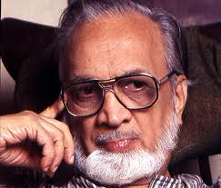

**Vijay Tendulkar**

[Author’s note: Photo from Google Images. I don’t know who would grant permission for this photo, or who his executor is, but could find out if needed.]

[Editor’s note: the image is available at: <http://www.outlookindia.com/article.aspx?2375> ]

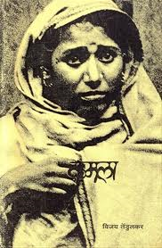

**Cover of the original Marathi edition of Kamala, Tendulkar’s play about human trafficking (Pune: Nilakantha Prakashan, 1982).**

[Editor’s note: this image is online at the following book dealer: <http://www.bookganga.com/eBooks/Books/Details/4732024277531636095> ]

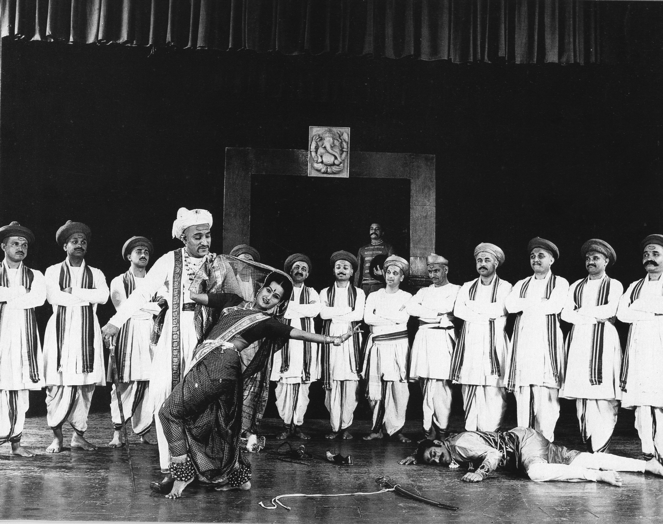

**Mohan Agashe as Nana Phadnavis, Rajani Chavan as Gulabi, and the “brahman line” in Ghashiram kotwal (Chief Constable Ghashiram), dir. Jabbar Patel, Theatre Academy, Pune, 1973.**

[Note from the author: Photo courtesy of Mohan Agashe and Theatre Academy. This is the third photo from my *Theatre Journal* essay (Decmeber 2013). If needed, I can ask Mohan Agashe to renew permission.]

[Editor’s note: I used this image in an article I published by the author in Theatre Journal and the author had no problem securing permission.]